Sales Process Handbook

Advisor Process & Procedures
Week 1 - Welcome Communications
New Client Welcome E-Mails / Texts (Everyone Gets These)
New Client Welcome Call Procedure (All New Students)
New Client Welcome Package
New Client Welcome Call Scripts
For clients who are attending
For clients who aren’t attending
If you get voicemail, leave this message
Week 2 - Intro Offer Communications
Week 3 - Intro Offer Communication & Call
The Upsell Call - classes (week 2)
For clients who are attending:
For clients who aren’t attending:
If you get their voicemail, leave this message:
The Upsell Call – appointments (week 2)
If they have been attending appointments:
Week 4 - Final Upsell Communications
E-Mails
Week 1 or 3 - Personal Follow Up Email
Week 1 - MB Auto Email New Client Welcome
Week 4 - MB - Time Running Out Email
Weeks 1-4 Constant Contact Templates
Week 1 Welcome E-mail
Week 2-4 Upsell E-mail
WorkFlow

The nature of being a boutique wellness business is that we have a continual “battle” of sorts with retaining clients and keeping our businesses viable. For class based businesses - Only 1 of 3 new clients will come back for a 2nd class! This is indicative of the huge opportunity we have to better communicate with our prospective customers so that we can connect them with the life enhancing services we offer, that we know they want and need. If they have walked through your door or searched for you online, they are really already a warm lead, so you need to ensure you are methodical and clear in what you have available to help change their lives. The following visual was printed behind my front desk to remind my staff of the process that they need to do for every customer.

This document was created by Roxy Banta Borger in operating her wellness business for 5 years and in her work consulting with wellness businesses since 2011 with www.liberatebizconsulting.com. There are also some great experts from Josh Boyd at www.the12.com. Thank you for downloading and we hope this helps you in defining your process! Feel free to download a copy of this and edit it and make it your own.

Welcome

Listen

Connect

So, we must focus on providing new students with the best, gold star experience possible the minute they walk through our door. This will enable them to experience the true transformative benefits that simply cannot be achieved in one visit.

Advisor Process & Procedures
The goal of the Advisor is to give our newest clients a little extra Customer Service love as well as ensure they are informed about pricing specials only available to them as newbies at our studio.

Week 1 - Welcome Communications

New Client Welcome Conversation

In-Person Conversation Details as written by one of the best sales people we know, Josh Boyd at The 12.
On the LIVE first visit please use the following approach.
If someone is NEW, instruct them that you want them to fill out the waiver form in full. While they do that, you will check people in and allow them to see how friendly we are and how we are connected to all our members. Once they are done follow this dialogue.
“First off, welcome to OUR STUDIO! I’ll walk you through the process to get you ready for your first class.
The first question we always ask is “How did you hear about us?”
And the 2nd question we ask is “Have you ever taken a Group Exercise Class Before?”
This is where you start walking them to the trainer/instructor. Ask them about their experience and what they liked or disliked about it. DON’T TALK, LISTEN and let them talk.
You aren’t trying to convince them of anything here, they already made the choice to workout. So, don’t blow it by talking too much.
Ok, so here is how this works. With this being your first class, go at your own pace. If you’ve taken a lot of these types of classes, you’ll get the hang of it fast. If this is new it might seem chaotic, but the teacher/trainer will be keeping a close eye on you. You’re not trying to lift the heaviest or go the fastest today. Today is your 1st date so to say! So, enjoy yourself and we get you all dialed in with your Intro Offer as soon as the class is over.
Remember these things:
We always provide Towel Service, Water, Mats, etc.
Please let the teacher/trainer know of any injuries you might have so we can make the proper adjustments and modifications.
When class is done I need you to come back to the front, so we can set up your First Month Intro Offer. We put all new clients on the Intro offer so that you can take as many classes you want and try all the teachers/trainers as well. We will also schedule your 2nd class.
Any questions? Awesome…. Enjoy class and I’ll see you right after class. If I am checking people in just hang out until I have a spare moment ok?
Enjoy your class!!!

New Client Welcome Package
Perhaps you offer a new client welcome package to help communicate and create connection with customers out of the gates. This could include schedules, links to apps, online scheduling logins, studio branded merchandise, need to knows, etc.

New Client Welcome E-Mails / Texts (Everyone Gets These)

(Day 1) - New Client Welcome Auto E-Mail - This is sent when a new client profile is created in MINDBODY in consumer mode (client signs up online themselves). It’s only sent in business mode (what staff uses) when we leave the ‘send welcome e-mail’ checkbox checked when adding a new client which we should do. It welcome’s clients to the studio, gives them a link to our online booking system, lets them know about the Intro Offer, and gives them basic studio etiquette. To see the specific e-mail go to MINDBODY > Toolbox > Auto E-Mails > “New Client Welcome (Business Mode” and “New Client Welcome (Consumer Mode) or see below in E-mail Templates section.

(Day 1) - First Visit Welcome Auto E-Mail - This is sent the night of their first class. It welcome’s clients to the studio, gives them a link to our online booking system, lets them know about the Intro Offer, lets them know that we will call them if they are on the Intro Offer, gives them the advisor e-mail if they have questions, lets them know about membership pricing, and gives them a link to take a new client survey and be entered into a drawing to win a free month of yoga. Whew, it’s a doozy. To see the specific e-mail go to MINDBODY > Toolbox > Auto E-Mails > “First Visit (Reservations)”.

(Day 1) - New Client Welcome Communication Sexier - You could always make this communication more professional using Constant Contact, Mailchimp, Loyalsnap, Brandbot, Frederick, or another e-mail / marketing service provider.

New Client Welcome Call Procedure (All New Students)
- Call on days 1-7
- Get list to call. Each Monday the studio manager will print a list of people who purchased the Intro Offer that should be contacted this week and put it in the advisor folder. This list is in MINDBODY > Reports > Sales > Sales by Service. Select Date Range at least two weeks ago, for one week long. Select Program = XXX. Select Series = “New Client Special”. Click Generate. Print.
- Lookup client. Review Visit History and get an idea for what classes they’re enjoying, or if they’re not and frequency of visits. Make note so you can bring this up in conversation. Also note expiration date, age, staff notes, and any contact logs before calling so best informed.
- Take a breath and give them a call. Remember this is a customer service call first and foremost.
- Chat per script/ideas below or leave a message. This should be personalized based on what you see in their visit history and what comes up in the call.
- Leave a contact log stating whether you talked or not (LVM or Chatted), that you sent e-mail (EM) or text, a sentence or two about the conversation, if you had one. Be sure to check the box contact log type = “advisor”.
  - Example of a good log
    - "Chatted and EM. She loves the studio and sounded interested in the membership."
    - "LVM and EM and TXT”
    - "Chatted and EM. Was apathetic and didn't sound like he'll be back. So sad."
  - Example of a not as good log
    - "made call."
- Check them off the list.
- Any random complaints, suggestions, feedback, please track it and send it via e-mail to the owner/manager after your calls. This process informs us about what we can do to improve the studio in the future.

New Client Welcome Script Website Lead

Phone Call Conversation Details as written by one of the best sales people we know, Josh Boyd at The 12.

Hi _____

This is ____ calling from OUR STUDIO. We’re just giving you an old-fashioned courtesy call to say Thank You for visiting our Website and requesting your X Free Sessions / More information.

First things first, let’s get you scheduled for your 1st class and get that out of the way. We’re going to create your profile for you. Once we do, you will receive an Email notification and Text notification. We have your name, email address & cell to get it started and then you can finish the profile with your other information when you download OUR APP / MB APP in the App Store.

What day and time would you like to take your 1st Class? (Client usually will ask about the schedule)
Now that you are all reserved here are the basics to know before coming to your 1st class.

NEED TO KNOWS:
The class is 60 Minutes. We have a 5-minute warm up, 5-minute explanation of workout, workout itself is about 45 minutes and then a 5-minute stretch/cooldown.
We have filtered water stations at all locations so be sure to bring a water bottle.
We provide fresh towels.
Arrive about 10 minutes early so we can introduce you to your trainer and you can inform them of any injuries or modifications we might need to make.
When class is done come back to the front desk to get your 1st Month Intro Offer.

The class is going to feel a bit chaotic for your first session but DON’T WORRY! The trainer will take great care of you. Feel free to go at your own pace.

First thing I want you to do is download the app right away when you get your Profile Creation Email from our system. This is how you will schedule your classes once you’re on your 1st Month Intro Offer.

Welcome to OUR STUDIO we look forward to seeing you at your 1st Class!!

New Client Welcome Call Script Everyone

The following is a script for what to say when calling clients for these calls.
Advisor says...

“Hi, my name is XXXX and I’m with XXXX. We’re calling our new clients who are on the Intro Offer to see how things are going and see if we can answer any questions regarding your experience at our studio (about classes, teachers, styles of classes, anything at all). “

Your goals:
- Give good customer service and inquire about how they are enjoying classes in open and honest way. Help guide them towards teachers and classes that you think will be good for them.
- Sign them up for their next visit. Encourage them to take advantage of the intro offer and to try a variety of services.
- Let them know about membership discount. In other words, If they are attending 1-2x/week and seem to be enjoying studio, bring up pricing discount. If they aren’t attending a lot, are from out of town, and are generally grumpy and/or not a good fit for us, then don’t bring this up and end with good customer service.

Helpful questions…

Are you enjoying things?
Can I answer any questions?
I notice you are enjoying “x teacher” or “x class”, you might also like this teacher or class if you are enjoying that one.
I notice you have only taken “one or two classes”, we hope you’ll be able to make it and enjoy the offer, is there anything I can do to help? Maybe we can book you for a class right now.
I’m sorry to hear about your recent troubles, if we extend the offer by a week, will that enable you to come in at least once more?

Listen to client response and respond accordingly. The following is an outline of what you might mention depending on the clients attitude and reception of the call.

- ALWAYS - Ask if now is a good time
- ALWAYS - Thanks for your time and business
- ALWAYS - Mention follow up e-mails for links, questions, concerns, feedback
- If they’re happy go lucky, open to conversing, mention they’ll be signing up for something soon - Mention membership discounts and class card options and any relevant expiration dates. Sign them up immediately and post date the start of the membership.

Some examples
Client: “I’m loving it and am very happy to chat with you about it!”
Advisor: We’re so glad to hear that! You have some time left as your Intro Offer will expire XX but we hope you’ll consider purchasing one of our memberships which are discounted right now/or just for you. I’ll follow up with an e-mail so you have our contact info and links to sign up. You can take advantage of the discounts online or in the studio. Hope to see you in the studio soon!

Client: “I’m enjoying it and don’t have much else to say about it”
Advisor: Thanks for your business and time. We’re so glad you’re giving our studio a try. If any questions or feedback crop up, I’ll follow up with an e-mail so you have our contact info.

Client: “I’m not really attending classes very much”
Advisor: Is there anything I can do to help you take advantage of your Intro before it expires? I can sign you up for a class right now or recommend teachers. Thanks for your business and we hope you’ll find the time to try out our studio a bit more. If any questions or feedback crop up, I’ll follow up with an e-mail so you have our contact info.

Client: “I’m not really into talking to you right now”
Advisor: Thanks for your time and for giving our studio a try. If any questions or feedback crop up, I’ll follow up with an e-mail so you have our contact info. Hope to see you on the mat soon!

For clients who are attending
“Hi, I am (your name), the fitness/yoga/Pilates advisor (or you can introduce yourself as the owner) from (your Business). I am calling to check in to see how you are enjoying the classes and find out if you have any questions or feedback about (insert name) business.”(wait for response)
“I notice you haven’t taken many classes.”(wait for response)
Try to motivate them, offer to sign them into classes so they can create a schedule, or address any issues that they may have.

For clients who aren’t attending
“Hi, I am (your name), the fitness/yoga/Pilates advisor (or you can introduce yourself as the owner) from (your business). I am calling to check in to see how you are enjoying the classes/enjoyed your session, and find out if you have any questions or feedback about (insert name) business.”
Find out how it’s going, see if they have any questions, let them know how to reach you.

If you get voicemail, leave this message
“Hi, I am (your name), the fitness/yoga/Pilates advisor (or you can introduce yourself as the owner) from (your business). I am calling to check in to see how you are enjoying the classes/enjoyed your session, find out if you have any questions or feedback about (insert name) business. Feel free to call me back at: (phone number) or e-mail me at (e-mail address).”

Week 2 - Intro Offer Communications
(Day 1) - Purchase Receipt Auto E-Mail / Text / Blurb - The following text is included on the receipt and sent via e-mail to everyone who purchases the Intro. We should also be saying this in person when they sign up and come in for their first visit: “***Thank you for purchasing our Introductory Offer!*** You have 30 days to experience the benefits of XXX and find a teacher and class that rock your world. If you find that you're enjoying the practice and attending 1-2x/week be sure to sign up for our membership before your intro expires and get a BIG DISCOUNT! We’ll be in touch or stop by the front desk to get more details on the membership discount. This series will expire 30 days from purchase.
(Day 7-14) - Send 2nd professional e-mail from Constant Contact, Mailchimp, Brandbot, Loyalsnap or another program or personal from studio. Same idea as welcome call - check in on how things are going, let them know about how to get help or give feedback, and let them know about upsell discount expiring soon.

Week 3 - Intro Offer Communication & 2nd Phone Call / Text

(Days 14-21) - Advisor Phone Call - See script and sample text above under ‘new client welcome call’ for specifics. This time focus more on upselling to membership. You should offer membership at $10-$30 off per month if they sign up before their intro offer expires. Remember your goal is to remove barriers, connect customers with life enhancing services.

In the case where they didn’t use the series at all, you are empowered to change the activation date of the Intro Offer just once. This is always a reminder that we need to be clear that it activates the day it’s purchased to anyone who purchases this series. The system will let them know this when they purchase it online and it will also get sent to them via e-mail with the purchase receipt if you e-mail it. It also prints on the receipt. You can edit the activation date by going to the clients profile > account details > click the little edit link next to the series on the top right.

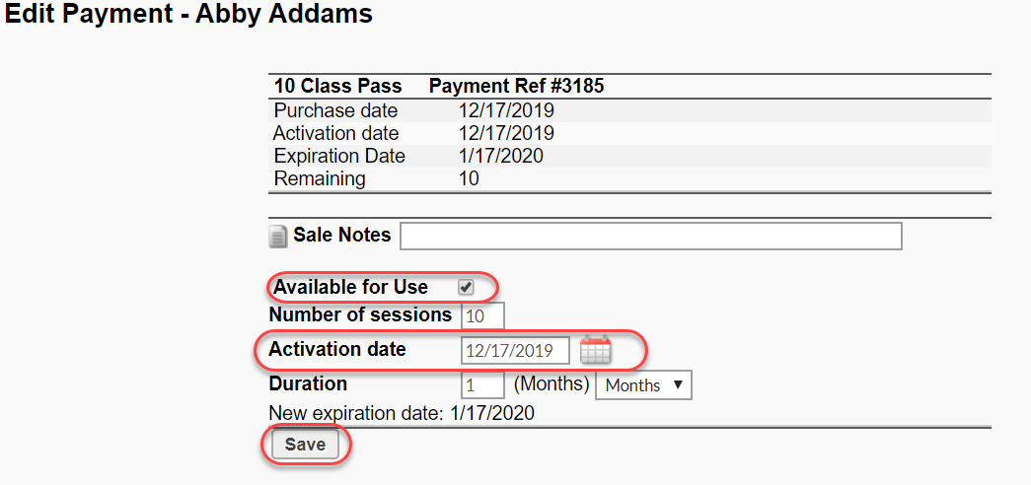

(Days 14-21) - 3rd Advisor E-mail / Text / Personal - See scripts below for ideas. This time focus more on Upselling and Conversions. You should offer membership at $10-$30 off per month if they sign up before their intro offer expires.

The Upsell Call - classes (week 2)

For clients who are attending:
“Hi, I am (your name), the fitness/yoga/Pilates advisor from (your business). I am calling to check in to see how you are enjoying the classes. I noticed that you have been coming a lot and I want to let you know you can save 20% off the membership price if you purchase it before the intro offer expires. This is our best deal and is only available during your intro month so be sure to take advantage of it now! You can use the following promo code to get this discount…”

For clients who aren’t attending:
“Hi, I am (your name), the fitness/yoga/Pilates advisor (or you can introduce yourself as the owner) from (your business). I am calling to check in to see how you are enjoying the classes.” (wait for response)
…if appropriate: “There is 1 week left on your intro package. You will receive a 20% discount off your next purchase if you buy it before the intro offer expires. This is our best deal and is only available during your intro month so be sure to take advantage of it now! You can use the following promo code to get this discount…”

If you get their voicemail, leave this message:
“Hi, I am (your name), the fitness/yoga/pilates advisor from (your business). I want to let you know that you can get a 20% discount off your next purchase if you buy it before the intro offer expires – (give them the date). This is our best deal so be sure to take advantage of it now! To purchase this you can call me back at (phone number) or e-mail me (e-mail address). You can use the following promo code…”

Week 4 - Final Upsell Communications
(Day 23) - Intro Offer Time Running Out Auto E-Mail - This e-mail lets the client know their Intro Offer is expiring soon (in 7 days) and encourages them to sign up for our memberships with the discount we’re offering. It also inquires about their overall experience and encourages them to contact us if they have questions/concerns. They will be alerted that they can get a discount on memberships if they sign up for one before their intro expires. The discounted memberships will show up for the student online or if we go to purchase for them as long as that Intro series is still valid.

(Days 23-30) - Front desk communicates with customers who are within their last 7 days to verbally check in with newer customers and offer upsell.

E-Mails

Week 1 or 3 - Personal Follow Up Email
The following e-mails are templates to be used to send to clients after calling them. The highlighted parts should be edited and formatted so they are specific to the client situation similar to notes above in the phone call scripts. These e-mails are copied in the ‘Yoga/Fitness Advisor’ folder in the info mail box. You can just forward and edit those.

Personal (1) STANDARD E-Mail to edit and send to student after call was made. Make adjustments based on conversation or what you notice on profile regarding attendance and what not.

First of all, thanks for giving OURSTUDIO a try! I called today and am dropping you a line to check in and see how your experience on our Introductory offer is going, and to also let you know about discounts we have available before your intro expires. We hope you enjoyed your classes and that you experienced the benefits of practicing yoga such as decreased stress, better sleep, increased flexibility, strength and so much more. If you have any feedback, questions, or concerns, don't hesitate contact us. <ADJUST / MAKE PERSONAL COMMENTS IN THIS PARAGRAPH>

OUR BEST DEAL: Get our MONTHLY UNLIMITED MEMBERSHIP (ADD HYPERLINK) for only $65 per month (regular price $80 per month) if you sign up before your intro offer expires! Pay only $7.50 per class if you attend two times per week, less if you attend more. This is the most cost effective way to pay for your yoga and we only ask for a 3 month minimum commitment.

If you prefer to pay per class, get 10% off the 5-PACK (ADD HYPERLINK) ($72 instead of $80) or the 10-PACK (ADD HYPERLINK) ($126 instead of $140) which have a one year expiration. You'll pay only $13-14 per class with these options.

If you like what you've experienced so far, right now is the best time to keep committing to your health and wellness with yoga. You may sign up online clicking the links above, give us a call, or stop by the front desk.

It is our mission to help you become a healthier and happier version of yourself with the practice of yoga and we hope you enjoyed being part of our oasis. We appreciate your willingness to give us a try and hope to see you on the mat. If you have any questions or concerns, let us know.

<your name>
<standard info email signature>

Week 1 - MB Auto Email New Client Welcome
TIPS: Add some beautification with bold & colors of text, hyperlinks to website and need to know pages, keep connected section with social media, mobile apps and maybe html images if you want to get really fancy.
-------------
Dear Joanna,
Welcome to XYZ Business!
I/We hope you enjoyed your first class/session. I/we encourage you to try a variety of teachers and classes/sessions to find the one that is right for you. Our staff and teachers are dedicated to providing you with an exceptional XXX experience. Please feel free to contact us/me with any questions or feedback you may have about XYZ Business.

Intro Offer – (30 Days Unlimited Yoga $30, 3 Pilates Sessions for $150)
If you haven't already taken advantage of our intro offer – 30 Days of Unlimited Yoga for $30, purchase it online or you can purchase it at your next class. This offer is for new students to experience as many classes at XYZ Business for the 30 days!
Yoga/Pilates/Wellness/Fitness Advice - e-mail or call
If you are on the intro offer, one of our XXX advisors will give you a brief call soon to see how you are doing, and if there's anything else we can do to improve your experience at XYZ Business. If you're not on the intro offer, and have some questions or would like recommendations on classes to attend, please email our advisor or call him at xxx-xxxx.

Use our online scheduling system:
This online system will enable you to see our schedule of classes and workshops and enables you to reserve your spot online. Book & purchase on our website using email/login: <CLIENTEMAIL> / <PASSWORDLINK>

Benefits of Yoga/Massage/Pilates/Fitness – It’s GOOD for you!
i.e., Yoga reduces the physical effects of stress on the body and eases physical pain and tightness. The practice teaches better breathing techniques, improves flexibility and body alignment. A regular practice can even help with weight management. We would advise practicing at least 2 times or more a week to start noticing positive changes in your body, mind and life.

Get a Discount on your next purchase!!
If you make another purchase before your 30 days is up on our intro offer, you will receive XXX discount! Ask your advisor for more information.
We welcome you to our thriving community and to the beginning of your journey.
XYZ Business
--------------------
Dear <CLIENTFIRSTNAME>,

Welcome to <STUDIONAME>! Learn more about upcoming yoga classes, massage, retail sales, workshops, and more by visiting us at <STUDIOURL>. We have included some helpful "need-to-knows" below. If you have any suggestions, comments, or requests about future services, then please let us know by replying to this e-mail, giving us a call, or in person. Thanks for visiting!

Benefits of Yoga & Massage - It's GOOD for you!
Studies show that yoga and massage are effective treatments in reducing the physical effects of stress on the body and easing pain and tightness. Yoga improves strength and flexibility, improves posture and mood, it teaches better breathing techniques and proper body alignment. We advise practicing yoga at least 2 or more times a week and/or getting a massage monthly to start noticing positive changes in your body, mind and life.

New Student Special - $30 for 30 days of unlimited yoga classes!
If you haven't already taken advantage of our Introductory Offer, you may purchase it online or you can purchase it at your next class. For the price of two drop-ins, this is the most cost effective way to give us a try. We also offer Yoga 101 workshops for those looking for
more attention and focus in the beginning.

We Care
You may have already met our amazing front desk team - our very own angels in the outfield. They are available anytime to answer your questions about classes, teachers, offerings, class styles, or pricing options. Just give us a call, stop by, or email us at wecare@smilingdogyoga.com. If you bought the new student special you'll hear from us soon.

Studio Etiquette
- Always arrive 10-15 minutes early for every class. We do not allow late entrance into our classes.
- Wear loose and comfy clothing.
- Stay hydrated. Water is available in the studio, but please bring your own refillable bottle.
- Bring a mat and maybe a towel. Don’t have a mat? Rentals are available for just $1 each and we also have them for sale.
- We have secure cubbies available for storing your personal belongings during class.
- Please mute cell phones and refrain from using them while in the studio and boutique.
- Inform your teacher of any injuries or ailments before class begins. Feel free to ask questions.
- Be clean of body and avoid perfumes.
- Always practice within your own limits, non-judgmentally, and with an open mind.
- Bun in the oven? Check out our pre-natal yoga offerings.
- Unsure which class to begin with? Read more on our website or contact us for more info.

K.I.T.
Keep In Touch with us! Check out our iPhone & Droid app that you can use to book and purchase on your smart phone. Book & purchase on our website using email/login: <CLIENTEMAIL> / <PASSWORDLINK>. We welcome you to our thriving community.

We deeply appreciate your willingness to give us a try and encourage you to visit our website or come see us in person again soon.

Yoga on,
The <STUDIONAME> Team
Web: <STUDIOURL>
Phone: <STUDIOPHONE>
----------------------------------

Week 4 - MB - Time Running Out Email
TIPS: Add some beautification with bold & colors of text, hyperlink to upsell membership, keep connected section with social media, mobile apps and maybe html images if you want to get really fancy.
---------------
Dear <CLIENTFIRSTNAME>,

Oh no, your <PRODUCTDESCRIPTION> expires on <EXPDATE>! We hope you were able to take full advantage of your class pass and experience the benefits of XXXXX such as improved health and wellness, decreased stress, increased flexibility, strength and so much more.

OUR BEST DEAL: Get our monthly membership for only $XX per month (regular price $XX per month) if you sign up before <EXPDATE>! Pay less than $X per class if you attend two times per week. **You have to be logged in to our website to actually see & get the discounted membership.**

THIS DISCOUNT EXPIRES on <EXPDATE>! If you like what you've experienced so far, right now is the time to keep committing to your health and wellness with yoga. You may sign up online clicking the link above, give us a call, or stop by the front desk.

We appreciate your willingness to give us a try and hope to see you on the mat. If you have any questions or concerns, let us know.

The <STUDIONAME> Team
Web: <STUDIOURL>
Phone: <STUDIOPHONE>

---------------------------

Weeks 1-4 Partner Communications & Details
We highly recommend using Constant Contact, Mailchimp, Loyalsnap, Brandbot, or Frederick or a similar email technology platform for email templates and campaigns for the following reasons.

It’s professional: It allows you to customize the design with logo, colors, and fonts. YOU can also insert photos, videos, social media icons, and call to action buttons that link to your MINDBODY site. Clients will be more likely to open something that is designed well, from a brand they recognize, and that invites them in with graphics, photos, and videos.

It’s easy: It’s intuitive to use, simple to create templates, and there are many “how to” videos for continuing education. Many partners now connect with MINDBODY to automate some of these communication steps saving you time and money.

Week 1 Welcome E-mail

The following screen shots are a bit old and are in the process of getting updated shortly!
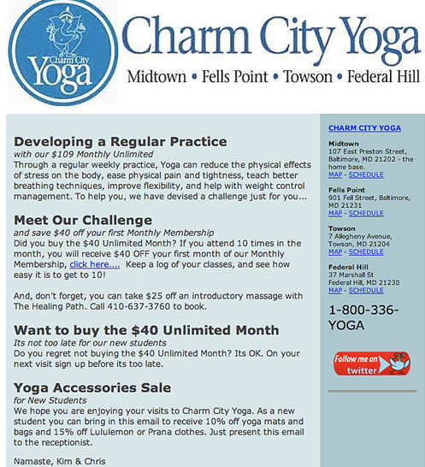

Week 2-4 Upsell E-mail
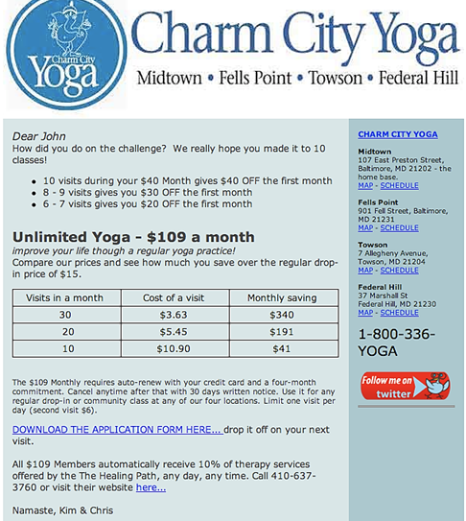

WorkFlow
Attempt to outline specific tasks here. Assign tasks to staff and schedule accountability check-ins.

- Weekly lists are printed, calls are made, follow ups are made, and emails are sent. These can be constant contact emails too.
- Monthly bonuses are calculated and documented and retention #’s reviewed and process improved.

